**Objectives:**

* Task 1: Provision the lab environment
* Task 2: Configure the hub and spoke network topology
* Task 3: Test transitivity of virtual network peering
* Task 4: Configure routing in the hub and spoke topology
* Task 5: Implement Azure Load Balancer
* Task 6: Implement Azure Application Gateway

**Architecture diagram:**

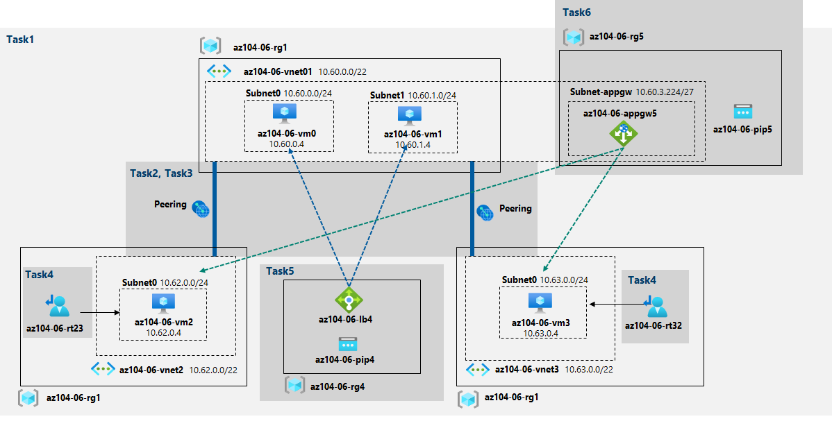

Task 1: Provision the lab environment

In this task, we will deploy four virtual machines into the same Azure region. The first two will reside in a hub virtual network, while each of the remaining two will reside in a separate spoke virtual network.

Here, we are create the three virtual networks and four Azure VMs into them by using the template and parameter files we uploaded earlier:

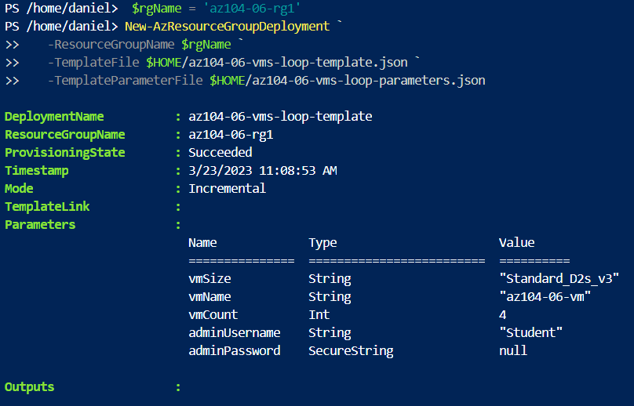

After that, in the Cloud Shell pane again, we are running the following to install the Network Watcher extension on the Azure VMs deployed in the previous step: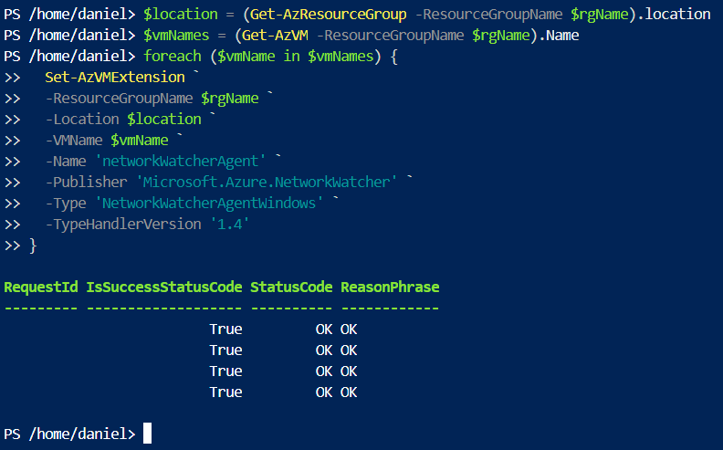

Task 2: Configure the hub and spoke network topology

In this task, we will configure local peering between the virtual networks that were deployed in the previous tasks in order to create a hub and spoke network topology.

Here we can see the 2 added peerings:



This step establishes two local peerings - one from **az104-06-vnet01** to **az104-06-vnet2** and the other from **az104-06-vnet2** to **az104-06-vnet01**.

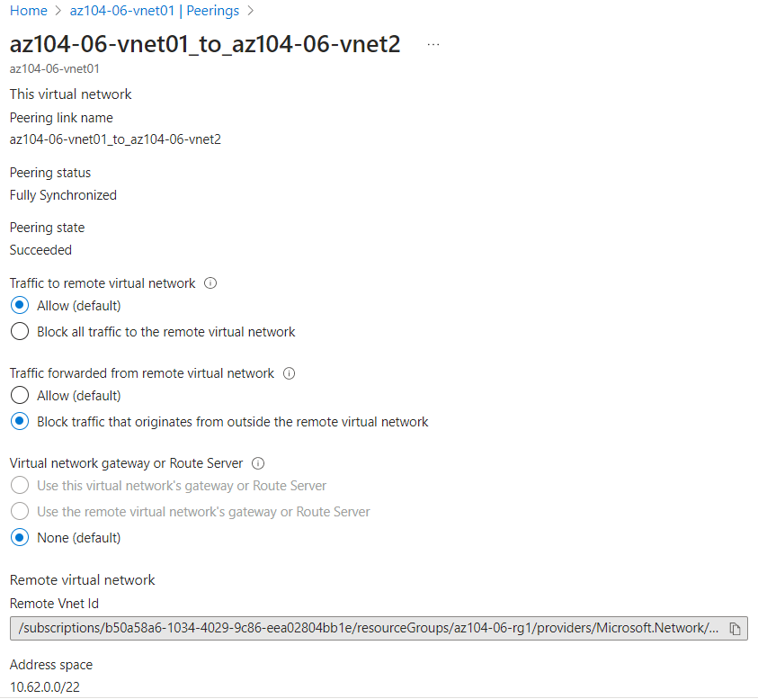

This step establishes two local peerings - one from **az104-06-vnet01** to **az104-06-vnet3** and the other from **az104-06-vnet3** to **az104-06-vnet01**. This completes setting up the hub and spoke topology (with two spoke virtual networks).

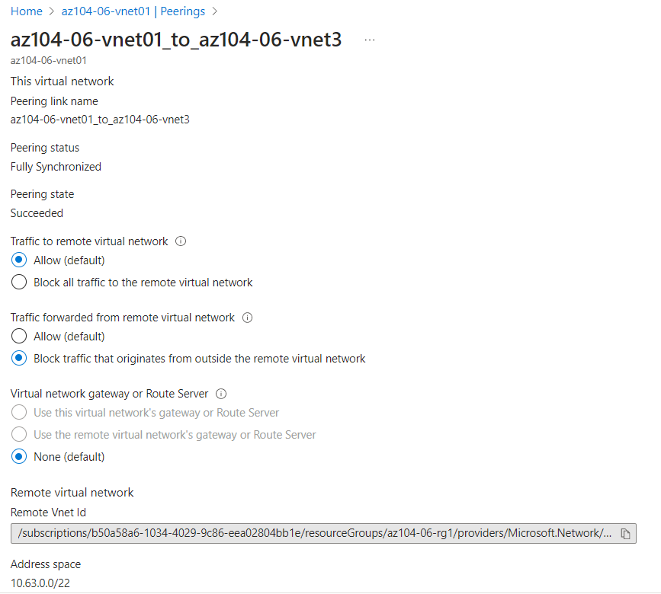

Task 3: Test transitivity of virtual network peering

Here, we will test transitivity of virtual network peering by using **Network Watcher -> Connection troubleshoot**. Since I had issues with Virtual machine (vm0) not appearing and trying lots of different troubleshooting steps, I selected vm2 then inputted the private IP address of vm0(10.60.0.4). Below we can see that the connection was successful:

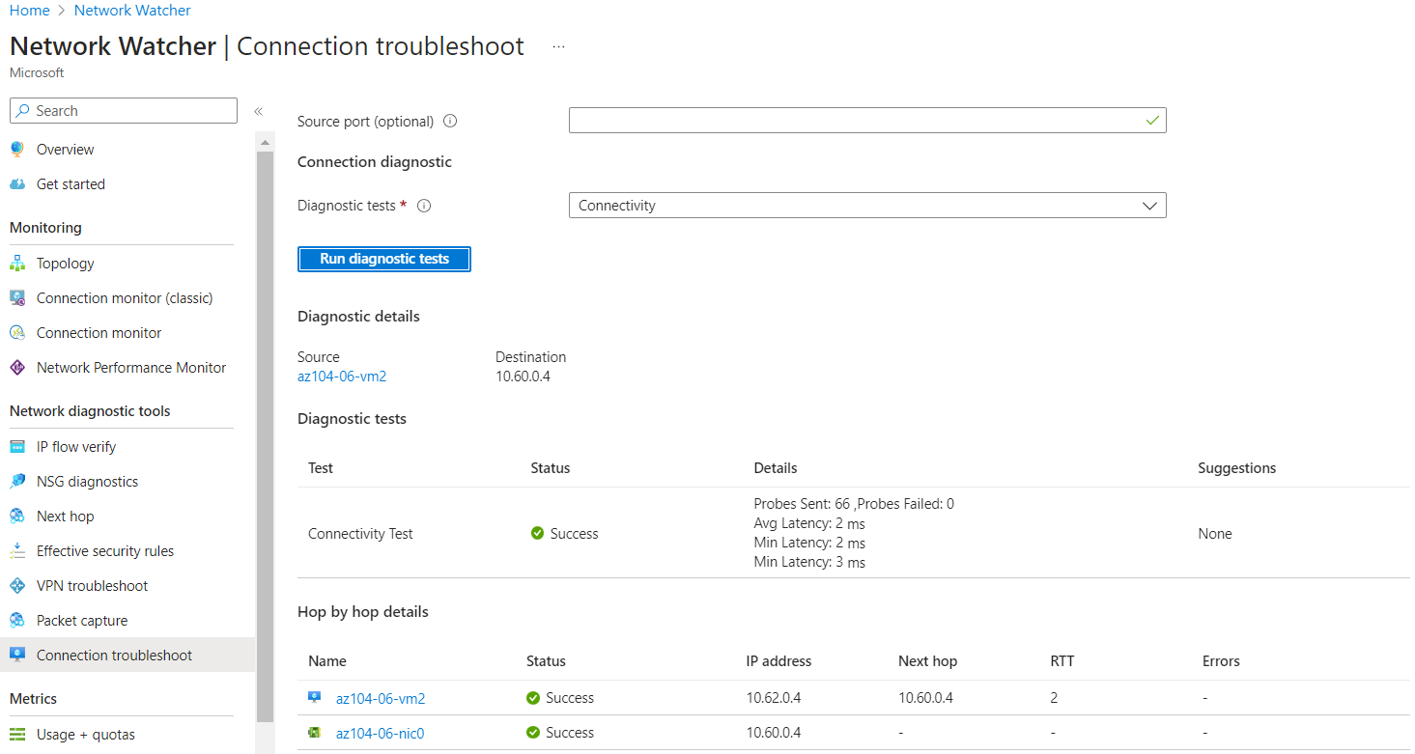

On the second test, we are using the IP of vm3(**10.63.0.4) and we can see that the test was successful again:**

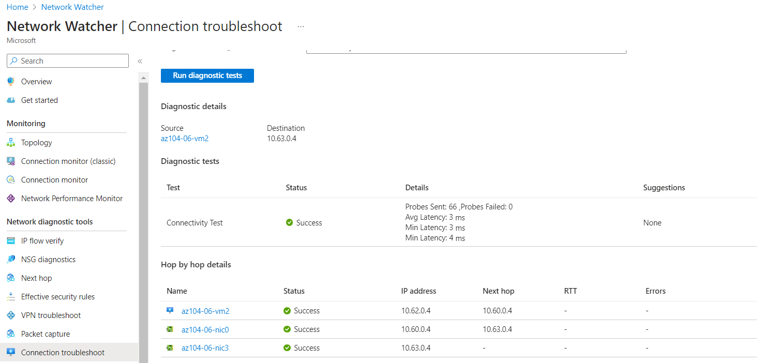

The third test would fail since the two spoke virtual networks are not peered with each other:

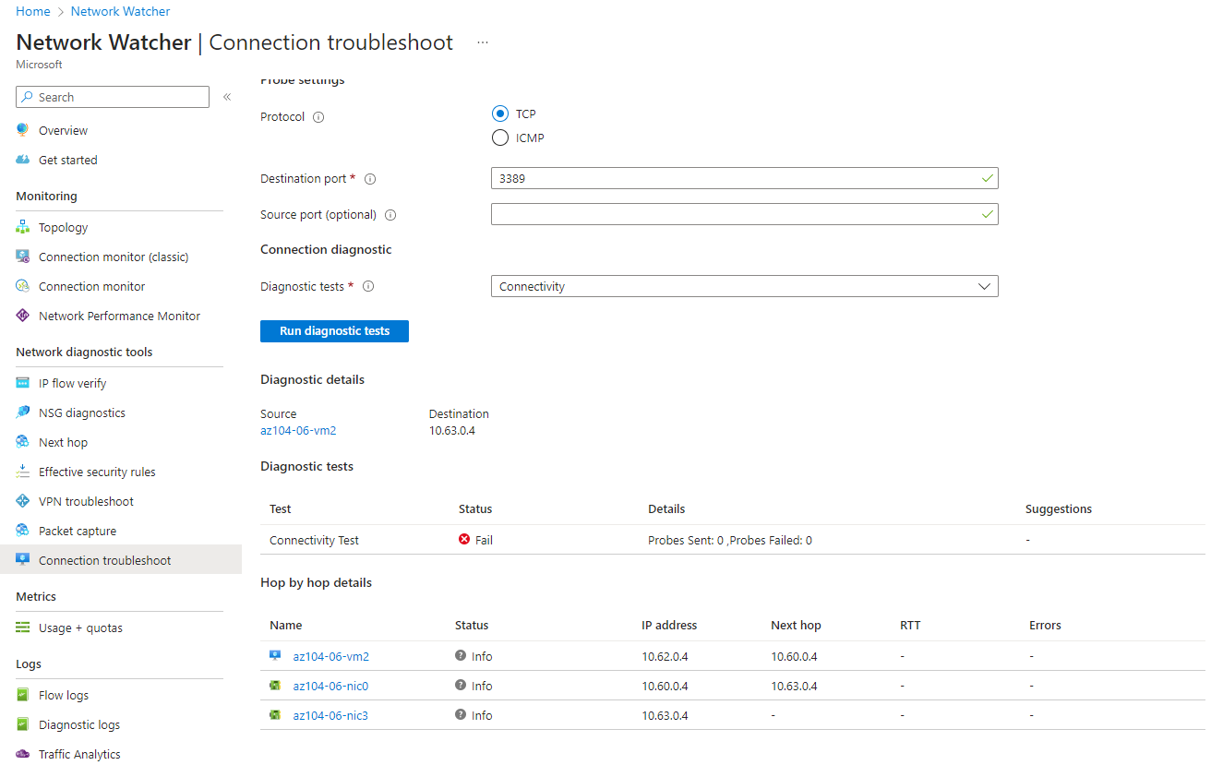

Task 4: Configure routing in the hub and spoke topology

In this task, we will configure and test routing between the two spoke virtual networks by enabling IP forwarding on the network interface of the **az104-06-vm0** virtual machine, enabling routing within its operating system, and configuring user-defined routes on the spoke virtual network.

First, we install the Remote Access Windows Server role through the Command Script blade:

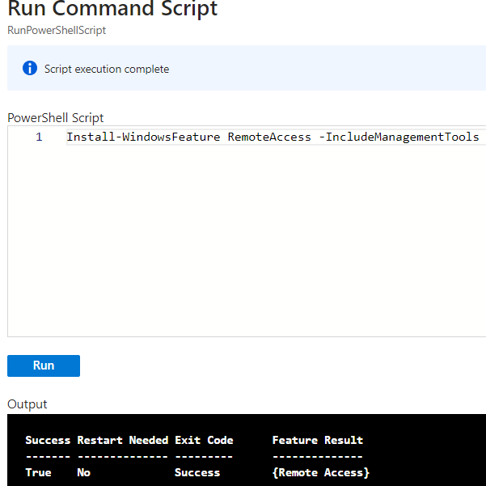

Then we install the Routing role service with the following commands:

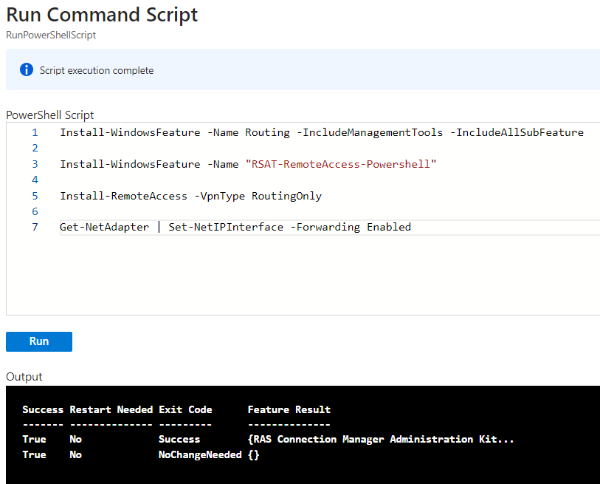

After this, we create 2 Routing tables and attach Routes and Subnets to them (following the steps in the guide):

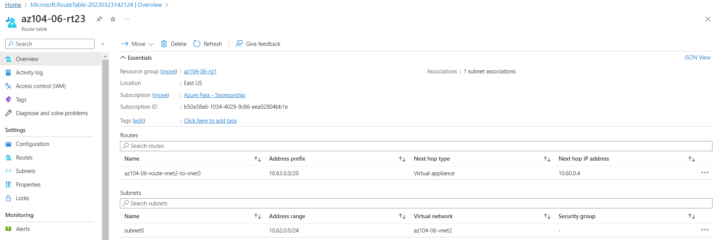

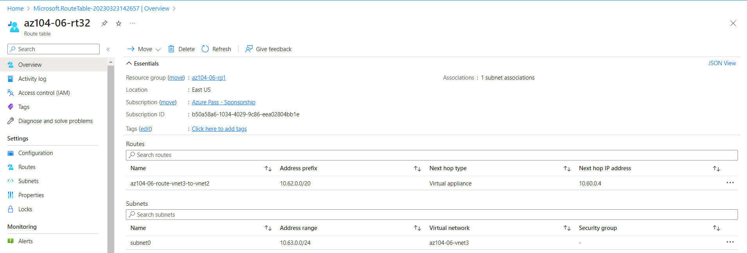

After this, we check the connectivity again through the **Network Watcher -> Connection troubleshoot** (inputting the required settings). We can see the successful status and that the traffic was routed via 10.60.04, assigned to the **az104-06-nic0 network adapter.**

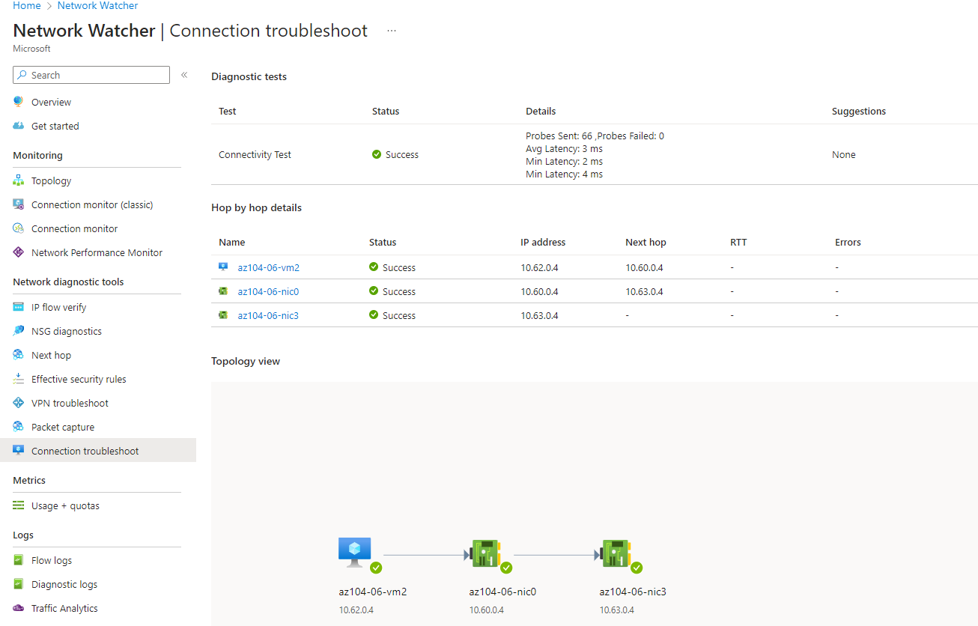

Task 5: Implement Azure Load Balancer

Here, we implement an Azure Load Balancer in front of the two Azure virtual machines in the hub virtual network and configure them as per the settings. After everything is completed, we open up a new browser tab, and navigate to the IP address (we take this from Fronted IP configuration in the Load Balancer resource group).

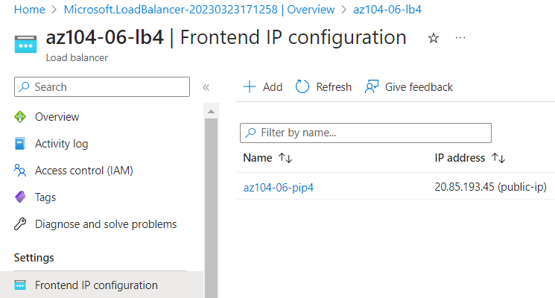

The browser window should display the message **Hello World from az104-06-vm0** or **Hello World from az104-06-vm1**.

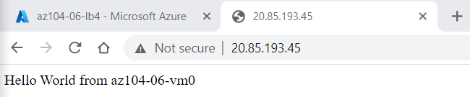

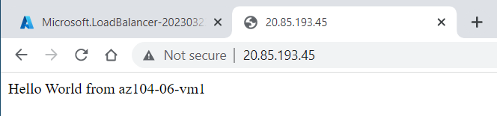

Task 6: Implement Azure Application Gateway

In this task, we will implement an Azure Application Gateway in front of the two Azure virtual machines in the spoke virtual networks.

Below we can see the deployed application gateway with the required specifications:

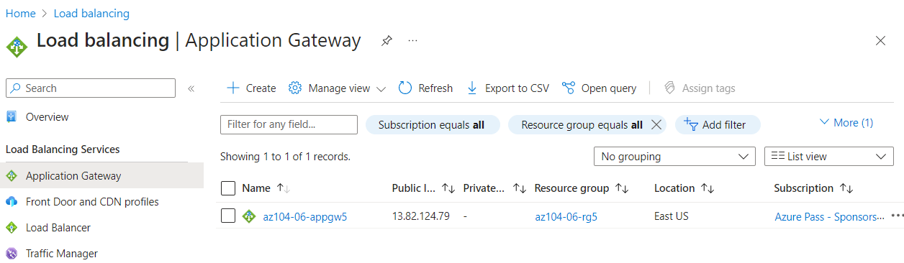

We now have to open up a new browser window and use the public IP address of this application gateway. This can be accessed when clicking on the **az104-06-appgw5** gateway -> **Frontend public IP address** (13.82.124.79)

The browser window should display the message **Hello World from az104-06-vm2** or **Hello World from az104-06-vm3**.

